------------------------------------------------------------------------------------------------------------------------
Important things to be known before running the 5G stack

1)before starting any process (Let it be for CN,gNB,UE) always first try communicating between all the Pcs using “ping <IP>”.Because if this only doesn’t work then nothing will work.
ex:- ping 192.168.1.53

2) for CN first bring up all the containers and then check if all are healthy and then check if AMF Registration is done and if the port that u have mentioned(most commonly used port : 38412) is Listening

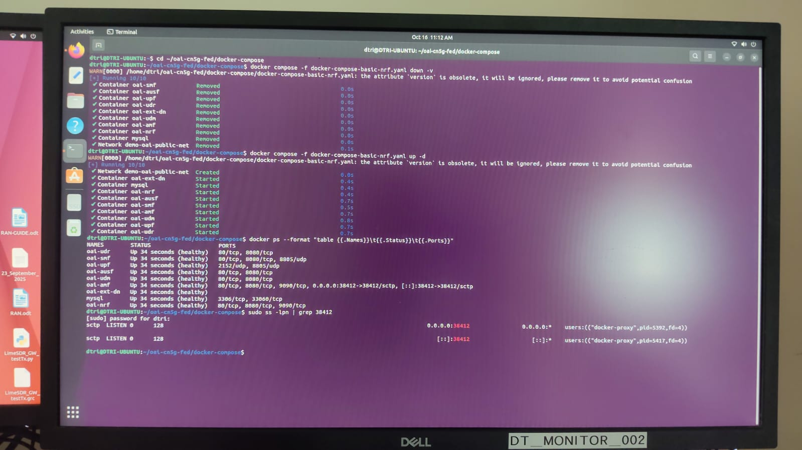
3) only after checking all these move on to observing the AMF heartbeat
4) For gNB first check which is the config/yaml file you are running and then write your IPs accordingly
5) while only connecting your CN <-> gNB make sure that the gNB is running as a client (usually runs as a client) but while implementing the whole stack CN <-> gNB <-> UE , the gNB should run as a client as well as the server , to do that either run it in the config/yaml file or in the command line itself(usually command line is more effective as it overrides the conf/yaml file).
6) The UE should be build properly if any libraries are missing or if it is not build properly it doesnt connect properly

7) For simulation mode no need to do much in the UE config file- just the “IMSI” , “KEY”, “OPC”, should be mentioned and that same should be registered to the CN in the “mysql” container
(every time you switch off and on , we must register the UEs subscription to the CN , because every time you turn down the container and then turn it up the subscription gets erased)

8) Please do read the hardware and software requirements before even starting to implement the 5G stack

The hardware and software that i have used is-------------------

OS: Ubuntu 22.04 for all the systems
PC_1 :- i3 core CPU for CN (had IP – 192.168.1.43)
PC_2 :- i7 core CPU for gNB (had IP – 192.168.1.53)
PC_3 :- i7 core CPU for UE (had IP – 192.168.1.45)

9) After the UE connects -
in gNB it shows [HW] client connects ifom ::ffff::<IP>
after that wait for som 10-15 mins because the chrony synchronizer takes time to synchronize so after that the clock , RACH , RRC and NAS gets synchronized and then that is reflected in the CN as ----

